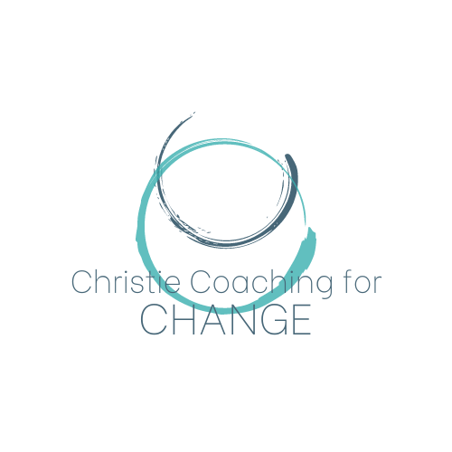

Privacy Notice

This statement confirms how I, Ailsa Christie, use and protect any information that you give to me whilst using this service. I am committed to safeguarding and protecting your information. If I ask you for any information it will only be used according to this privacy statement.

I may change this policy from time to time in line with legislation and whilst we are still working together I will notify you of any change. If we have ceased working together and you would like a copy of my up to date privacy policy, I will provide one on request.

Information that I collect: I store your name, telephone number, email address and other information that you have provided me with. I record most sessions using Zoom Audio/Video and use Otter ai transcripts.

How I store information All information is stored electronically and password protected and all digital files are destroyed 7 years after your sessions end, unless agreed otherwise. I will share recordings/transcripts with you upon written request. Your contact and appointment details will be kept for 7 years after your sessions end and then destroyed, unless agreed otherwise. Any emails, texts or other messages will be deleted over time but no later than 7 years as above. Your telephone number is stored on my phone only as your first name. If I change phones, then I will factory reset the old phone and everything will be removed. I store a note of your appointment in my password protected online diary. This is also kept for 7 years.

How I use this information: I will use your contact details to engage in my work with you according to my contract, including contacting you about appointments, keeping records such as appointments, and running and maintaining my business. I also keep transcripts of coaching sessions in order to support me in offering you coaching. I will not use contact information or session notes for any other purpose than this notice and my contract. If for any reason I am asked to provide a report of the sessions – e.g. at your request – then this will be sent to you, password protected for your approval before it is provided to the person requesting it. It will also be stored for 7 years.

Your rights to access information: You have the right to see any information that I hold about you. Unless prevented so by legal reasons, I will provide this information to you within a month of your request. I am also happy to look at this within a session. You have the right to ask me to change any information that I hold that is incorrect and ask me to delete any information that I hold about you. I will do this except for any information I need to hold for legal purposes such as business tax purposes.

Complaints: If you wish to complain about how I hold your data in any way, then in the first instance, please contact me, Ailsa Christie at christiecoachingforchange@outlook.com
If you have any further complaints which are not addressed, you should then contact the Information Commissioner’s Office at hhtps://ico.org.uk/concerns/handling or 0303 123 1113.

Breaches: I will report any data breach to the Independent Commissioner, to BACO and to yourself within 72 hours if it becomes apparent that any data is stolen. My data protection reference is ZB710664

Contact: If you wish to contact me with questions, concerns, complaints or request your information, please discuss in session or contact me at christiecoachingforchange@outlook.com

Updated on 31/07/2024

